**Title of your Manuscript (This should be less than 15 words)**

First Author’s Name (e.g., Jane Smith)

First Author’s Affiliation (e.g., RETS University)

Second Author’s Name (e.g., John Smith)

Second Author’s Affiliation (e.g., RETS University)

*Key words*: Please provide 2–5 key words here

[please insert a space here]

**Basic Idea or Introduction (Level 1 Heading)**

If English language teaching methods are the focus of your article, then please describe here the basic ideas of the methods that you will talk about in this article (e.g., issues/motivation that led you to invent/adopt a particular teaching method for your classes and the theoretical background behind your method). You can divide this chapter into several sections if you would like to do so. In that case, please follow the heading styles shown in what follows. As for in-text citations, RETS follows the style of the Publication Manual of the American Psychological Association, Sixth Edition (cf., <https://owl.english.purdue.edu/owl/resource/560/02/>)

If your article focuses on language education policy, then please briefly introduce an agenda that you will discuss in this article (e.g., issues/motivation that made you decide to discuss a particular topic in this article). You can divide this chapter into several sections if you would like to do so. In that case, please follow the heading styles shown in what follows. As for in-text citations, RETS follows the style of the Publication Manual of the American Psychological Association, Sixth Edition (cf., <https://owl.english.purdue.edu/owl/resource/560/02/>)

[please insert a space between Level 1 and 2 headings]

**Level 2 Heading**

**Level 3 Heading.** This index…

***Level 4 Heading*.** The sub-scale of…

*Level 5 Heading.* The smallest part of…

[please insert a space between chapters]

**Materials and Implementation or Discussion (Level 1 Heading)**

If your article is about the method of your English language teaching, then please introduce here the materials and implementation methods that you are using (or have used) in your classroom. To make it easy for your readers to understand your teaching context and assess the feasibility of adopting your methods to their own class, we strongly recommend the following to each author: (a) please make clear the general information of your class, i.e., students’ age range, major, gender ratio, and English proficiency, and typical class size. Regarding English proficiency, you are encouraged to explain the (expected) level of your students referring to [The Common European Framework of Reference for Languages](https://www.examenglish.com/CEFR/cefr.php) (e.g., A2 in CEFR); (b) please describe the (typical) way of implementing your teaching methods (e.g., activities included in each stage of a task); and (c) please provide URL or a domain from which we can retrieve your teaching materials unless copyright issues prevent you from doing so. If copyright issues are a barrier, then please tell us the domain in which we can purchase this material (e.g., Amazon website) or to which we can send a request for permission to use given materials in our classes (e.g., right holders’ e-mail address). You can divide this chapter into several sections if you would like to do so. In that case, please follow the heading styles shown in what follows.

If language education policy is what you wish to discuss in this article, then please develop your arguments in this chapter. To help your readers to understand the value of your article and follow your rationale, you are encouraged to develop your argument in line with important literature on a given topic. Also, except where the discussion on a given topic is largely limited worldwide, it is our recommendation that this chapter covers recent literature as well as the classics. You can divide this chapter into several sections if you would like to do so. In that case, please follow the heading styles shown in what follows.

[please insert a space between Level 1 and 2 headings]

**Level 2 Heading**

**Level 3 Heading.** This index…

***Level 4 Heading*.** The sub-scale of…

*Level 5 Heading.* The smallest part of…

[please insert a space between chapters]

**Benefits or Future Directions (Level 1 Heading)**

If your article is dedicated to the method of English language teaching, please show benefits that we would expect to attain from the implementation of your methods. You are recommended to build a rationale based on (a) data at hand, (b) relevant theories and research findings, or (c) a combination of both. The data here can either be quantitative or qualitative. Some authors, for example, may wish to show a pre-post difference though statistical analysis; meanwhile, the others may like to introduce positive reactions, comments, or more structured feedback from their students and colleagues. Reports on the (potential) problems and inconvenience attached to your methods are greatly appreciated as this helps readers to deal with such drawbacks in their future teaching practice.

If your article is dedicated to language education policy, then please indicate future directions for English language teaching based on your previous discussion. Topics that can be covered here are, e.g., efforts must be made towards the creation of more learner-centered or learner-friendly environments in English language courses and English-mediated courses. It is recommended that you also mention the problems that we need to tackle before the realization of more successful English education, and the type of supports and resources needed in the future.

[please insert a space between the main body and tables]

**Table 1**. Example

|  |  |  |  |
| --- | --- | --- | --- |
| Title | Text type | Length | The CEFR level |
| The Big Baby | Narrative story | 1,000 words | A2 |
| The Big Baby 2 | Narrative story | 2,000 words | B1 |

*Note*. CEFR = The Common European Framework of Reference for Languages.

[please insert a space between the main body and tables]

[please insert a space between the main body and figures]

*Figure 1*. Example 2

[please insert a space between the main body and figures]

[please insert a space between the main body and figures]

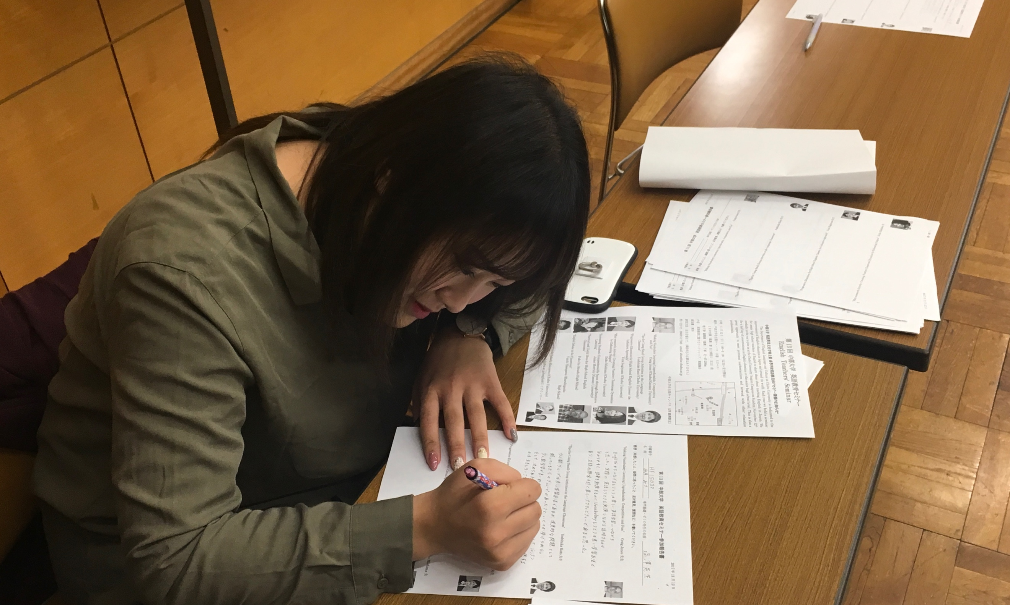

*Figure 2*. Example 3

[please insert a space between the main body and figures]

**References (alphabetical order by the author’s last name)**

[Journal Articles]

MacIntyre, P. D., Noels, K. A., & Clément, R. (1997). Biases in self-ratings of second language proficiency: The role of language anxiety. Language Learning, 47, 265–287.

[Books]

Grabe, W. (2009). Reading in a second language: Moving from theory to practice. Cambridge: Cambridge University Press.

* *Non-English books*

Kanamaru, T., & Educational Testing Service. (2012). TOEFL® ITP test koushiki test mondai & gakusyuu guide. [The official TOEFL® ITP tests & guide]. Tokyo: kenkyu-sya.

* *Digital/Online books*

Educational Testing Service. (2016). *TOEFL ITP Test Taker Handbook*. Retrieved from <https://www.ets.org/s/toefl_itp/pdf/toefl_itp_test_taker_handbook.pdf>

[Websites]

Dubner, S. J. (2017, November 8). How can I do the most social good with $100? and other FREAK-quently asked questions. Retrieved from <http://freakonomics.com/podcast/how-most-social-good-100-dollars-other-faq/>

* *No author*

Professor Mitsuo Sawamoto (Institute of Science and Technology Research) receives the Benjamin Franklin Medal. (2017, May 16). Retrieved from <https://www3.chubu.ac.jp/main/english/news/11428/>

* *No date*

The Edinburgh Project on Extensive Reading (n.d.). Retrieved from <https://www.er-central.com/the-edinbugh-project-on-extensive-reading/>

[Other Non-Print Sources]

* Please refer to the Purdue OWL: <https://owl.english.purdue.edu/owl/resource/560/11/>

**Appendix**: Example

1. XXX.
2. XXX.

**About the Author (Example)**

**Jane Smith** is an English teacher at RETS University. She was born in Aichi and grew up in an English–Japanese bilingual home. She received her BA (in drama) from RETS University. Jane has over 10 years of experience in English language teaching, and throughout her career, she has been very keen to apply dramatic methods to English language teaching. The project introduced in this article is one example of such practice.

*E-mail*: [CU_RETS@excite.co.jp](mailto:CU_RETS@excite.co.jp)

**John Smith** is …

*E-mail*: [CU_RETS@excite.co.jp](mailto:CU_RETS@excite.co.jp)